Background:
About a year ago, I designed a Customer Service: Building Relationships professional development session (Appendix A). About a month ago, I shared this design with a group of friends, and one of them has a new company where they provide, among several services, graphic design work to private and corporate clients. Their team is composed of 4 designers, and they all interact directly with the clients. The owner of this company asked me to spend 2 hours with the group and deliver this training with the goal of improving their relationships with clients.
Philosophy:
When it comes to assessing learners, I believe in getting to know what they already know about the subject. I also prefer to assess them through the whole class to avoid any disconnections between the theory and the practice of the lesson. These assessments during class are always anonymous to focus the evaluation on the whole class, but at the same time allowing each learner to feel comfortable to speak up if they needed personal attention on a part of the training that they did not understand. Additionally, since I always incorporate a practice of what we have learned, this approach becomes my final check, and helps me to see if the learners are ready to use these skills in the real word. Lastly, I like to give the learners a tool for self-assessment that they can use anytime outside of class. This last evaluation will also help the learners to keep thinking about what we had learned, and encourage them to keep working on the skills that they still need to develop.
What and How the learners got assessed:
To be able to get the assessment plan started, I came up with a few objectives:
- Given different phrases on how to build a positive and strong relationship with clients, the learners will identify which one should be used on each of the 6 steps learned with 75% accuracy.
- When given a case scenario profiling a first time client, the learners will be able to describe what they would do to help the customer by following the steps learned with 75% accuracy.
- Given a list of questions, the learners will be able to reflect on their practices and make changes in their actions as needed, or will be able to ask for help to be able to modify certain behavior by a specific period of time.
Then, I used the following tools to assess the learners:
- To understand what the learners already knew, I used the CAT 1: “Background Knowledge Probe”. To obtain the results on this CAT before the workshop started, I emailed the learners the following questions using an electronic survey:
- Who are your customers?
- What do you consider a bad customer service experience? Please describe your personal experience as a customer in detail.
- As a customer yourself, do you usually share your bad or good customer service experiences with family and friends?

- During the session, I wanted to know how much of the materials they were grasping; therefore, I used another CAT to assess this knowledge. CAT 20: “What’s the principle?” was a good base to design this test.
- “You mentioned wanting to add news about the COLTS on your website, do you go to see the games often?... I love going to see the COLTS games myself” (Answer: Establishing Rapport)
- “I know you have been having a hard time moving the logo to the other side of the page, our new ‘X’ tool helps us to move it without having to rewrite the material you already have in this page. With this tool, we will have this problem solve for you in just a few minutes!” (Answer: Interacting positively with customers)
- “It looks like I have a good understanding of your needs; you are looking at changing the color of the background on your site, and modifying your logo to better match your product. Does it sound as I am on the right track?” (Answer: Identifying customer’s needs)
- “You have been a great customer, Charles. Let me help you with that extra logo that you need for your fundraiser for no charge” (Answer: Make the customer feel valued)
- “How was your daughter’s game yesterday?” (Answer: Maintain ongoing relationships)
- “I am very sorry for the misunderstanding Mr. Smith. We will reverse the charges as soon as possible (while keeping calm when the customer is being pushy)” (Answer: Handling difficult clients)

- Closer to the end of the session, the learners will be able to put their knowledge into practice by participating in role plays, helping each other by analyzing the performance, and discussing which one of the steps should have been used when dealing with a first time customer. This activity allowed me to assess their usage of the theory in a more practical way, and encouraged the learners to keep practicing how to handle different customers in alternative situations.
- Lastly, I gave the learners a list of questions for them to self-assess their behavior and either change it from what they had learned on this session, or ask for support if they still need extra help with this topic:
- Do I interact positively with my customers? What can I do to make sure I do?
- How well do I ask questions to identify what my customers need? How well do I summarize what the customer said and then offer the best solution? How can I improve?
- What do I do to show my customers I value them? How can I improve my skills?
- How do I get to know my customers better? What can I do to strengthen relationships with our repeat customer?
Analyzing the results
CAT 1: “Background Knowledge Probe” gave me great insight on what the learners understood of the topic and what their experiences as customers themselves were. With that information, I was able to make a few modifications to my design and use their experiences on my examples, so they were familiar stories. This experience was great, and I will keep using this CAT in future training sessions, so I have practical information about the group, and get the learners interested and motivated by using examples that are relevant to them.
CAT 20: “What’s the principle?” was a success. The learners were able to recall the information learned and apply the principles while analyzing the phrases provided. They even were able to come up with other examples that represented the steps that we were speaking about. Perhaps, in future sessions, I can divide the class in groups, so they can work together on those phrases, and ask them to come up with new ones to share with the whole class as part of the assessment itself, since it seem to work well with this group even though I had not planned to add anything else to this activity other than having them recall the steps.
The role plays are always part of my lessons, and using this activity as a way of assessing their learners’ knowledge in a practical approach always helps me to feel comfortable with what we are doing because I know they will be able to apply these new skills on their jobs. Because of its success, this is absolutely a type of evaluation that I will keep using on my sessions.
I don’t have any feedback yet on the self-assessment questions that I gave the learners to evaluate their skills while working with customers. However, I like the idea of using this type of assessment to keep the learners interested in the topic, and encourage them to research more about the topic or ask for help to their managers if needed.
Overall, the session was fun, and the learners showed great improvement through the different assessments we did during the 2 hours session on building relationships with clients. The assessment plan was a great guide of reflection about what I believe learner’s evaluations should be all about, and how they work in a real life training session.

Appendix A

1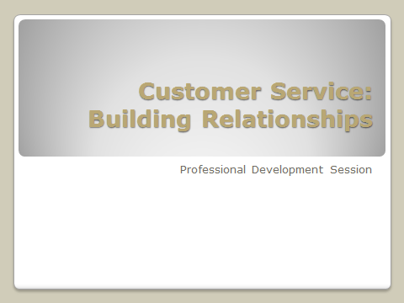
2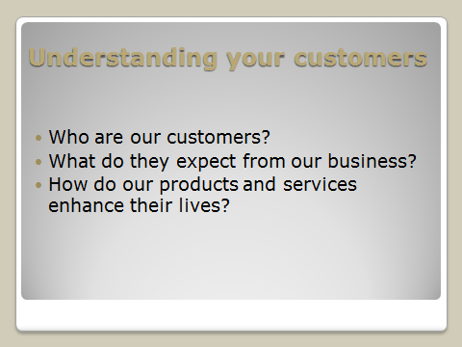
3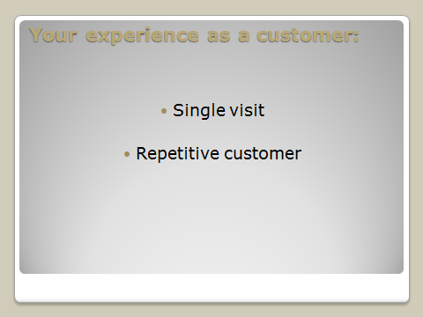
4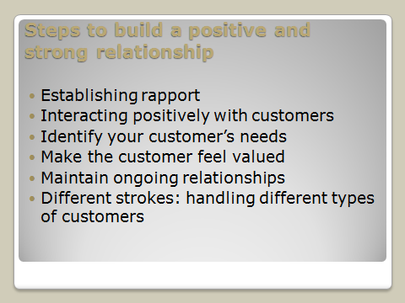
5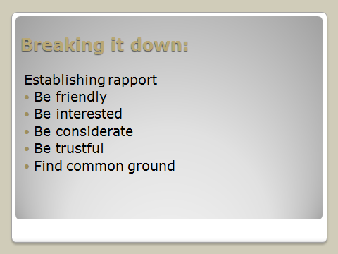
6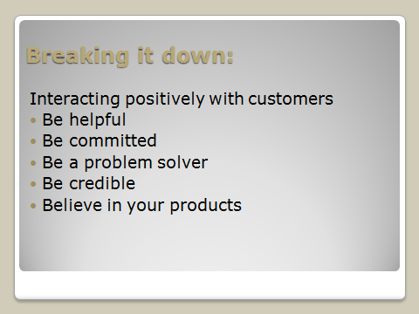
7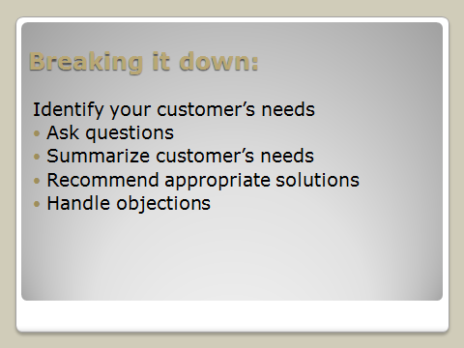
8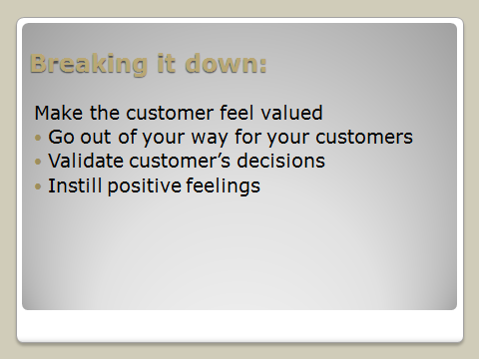
9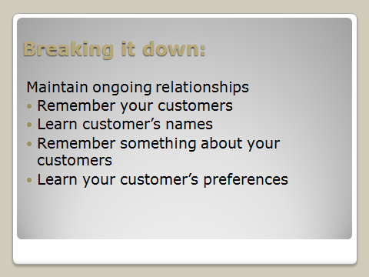
10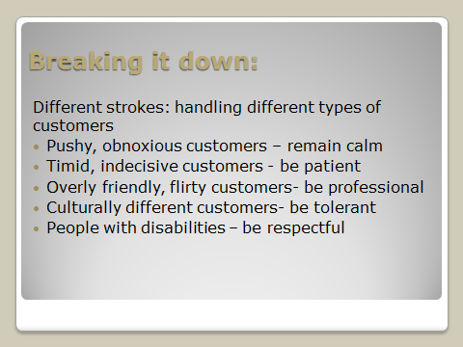
11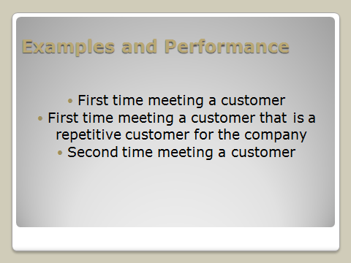
12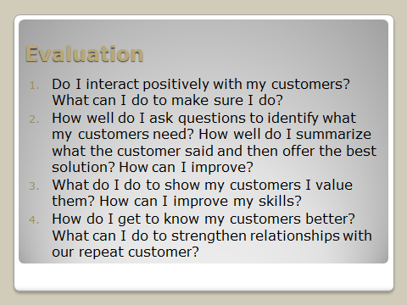
13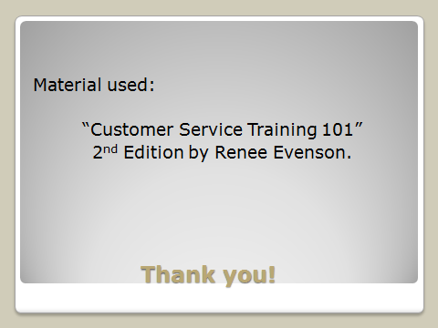

Reference List
Cross, K. P., & Angelo, T. A. (1993). Classroom assessment techniques: A handbook for college teachers. Ann Arbor, MI: National Center for Research to Improve Postsecondary Teaching and Learning, University of Michigan.
Evenson, R. (2010). Customer service training 101: quick and easy techniques that get great results. AMACOM Div American Mgmt Assn.

